|  |  | UNCOVER THE CRIMINAL  Welcome Detectives! |
| --- | --- | --- |

In an English country house called Tudor Mansion, a mysterious series of events has unfolded. The renowned detective, now retired, has left behind a set of coordinates leading to clues about the culprit and their accomplice involved in those crimes. As aspiring detectives, your task is to decode these coordinates and uncover their identities.

The following is the list of suspects:

* Miss Scarlett (Nickname: Scar)
* Colonel Mustard (Nickname: Cole)
* Mrs. White (Nickname: Whit)
* Reverend Green (Nickname: Gren)
* Mrs. Peacock (Nickname: Peac)
* Professor Plum (Nickname: Plum)

# PART 1: IDENTIFYING THE CULPRIT

**INSTRUCTIONS**

1. You are given a series of images. You have to find the name of the city where the image was taken.
2. You need to find the correct combinations of letters extracted from these city names that when decrypted using Caesar Cipher, reveal the name of our culprit.
3. Use the Caesar cipher table to decrypt the word and get the name of the culprit.

**IMAGE 1**

## Significance of Stonehenge | English Heritage

**IMAGE 2**

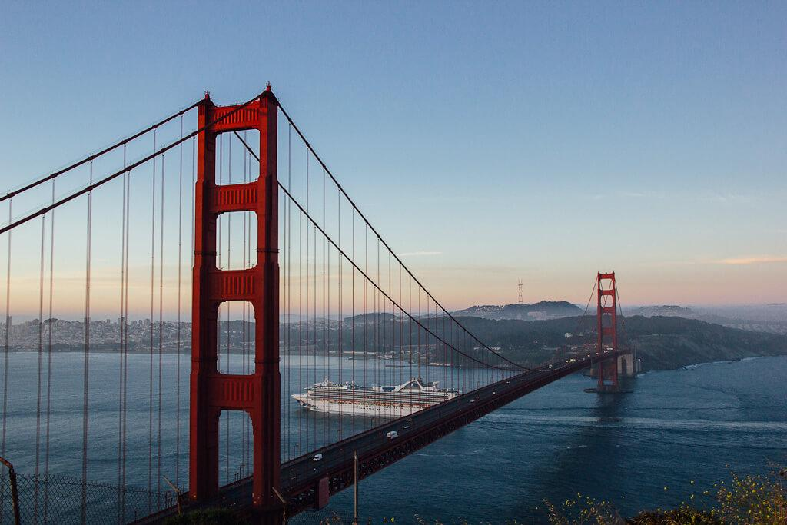

**IMAGE 3**

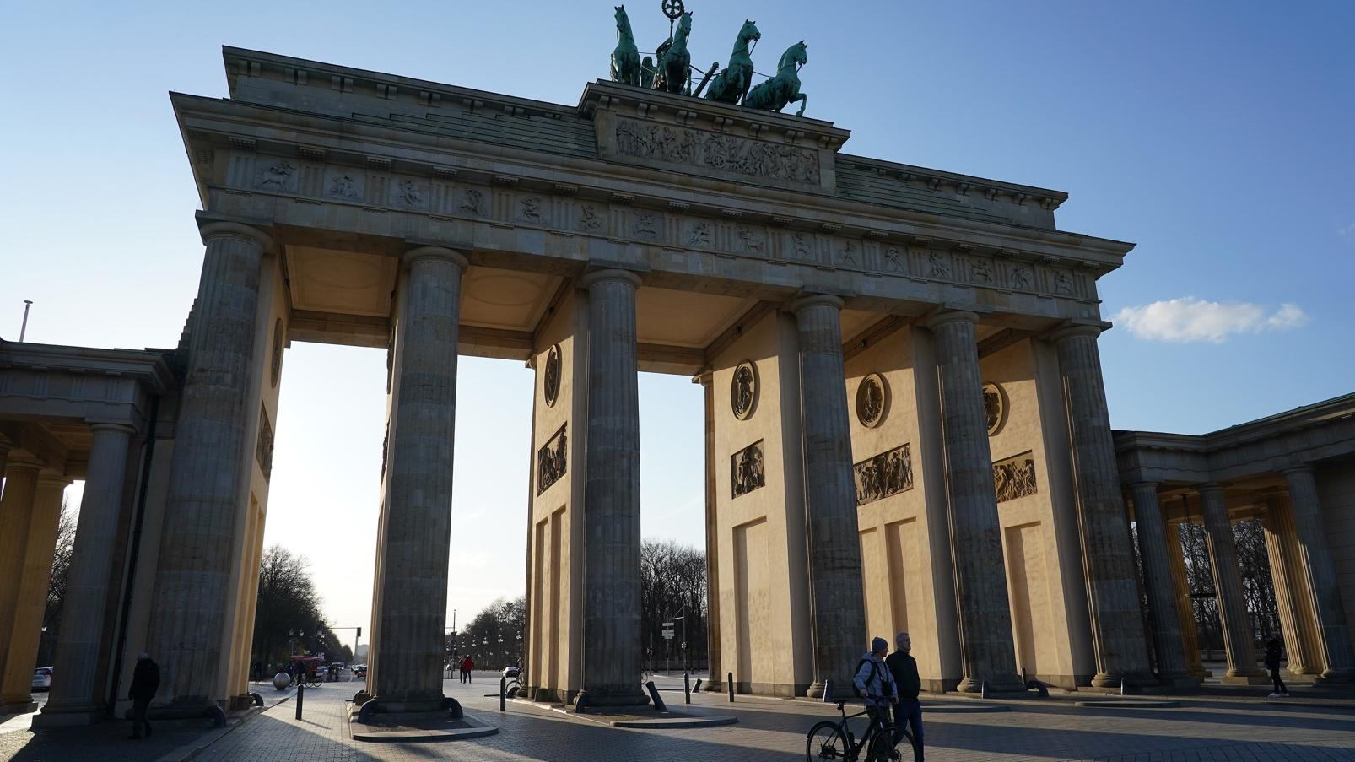

## 

## IMAGE 4

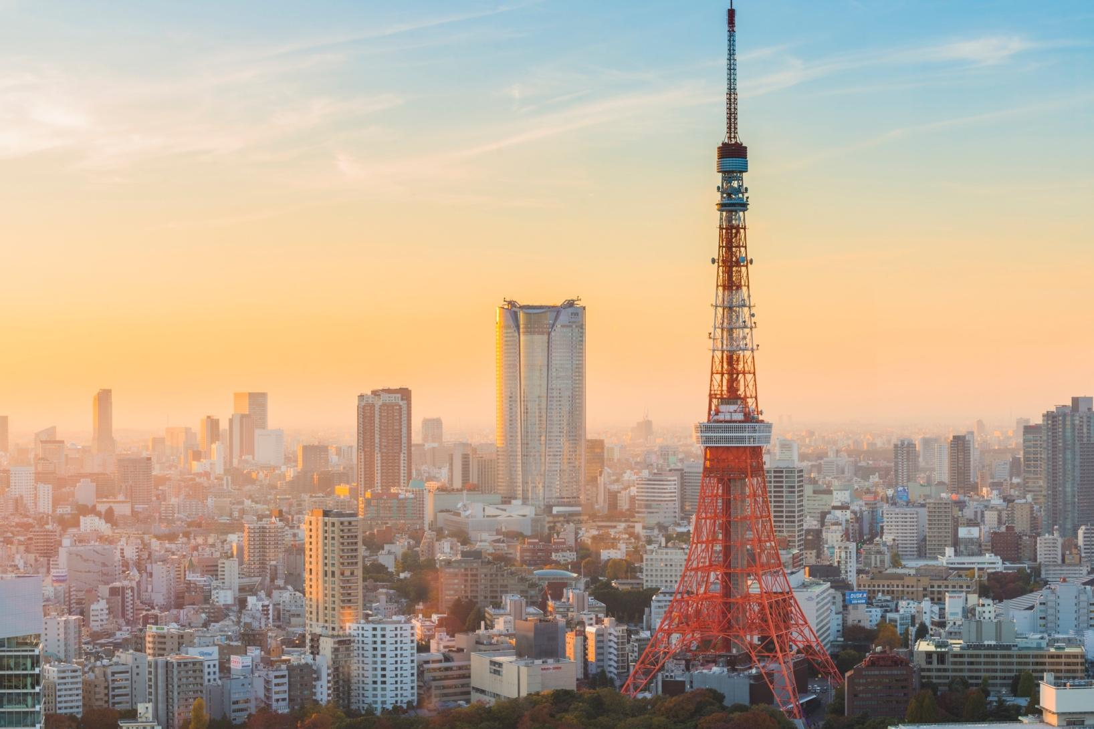

## CAESAR CIPHER TABLE

You can use the following table to decode:

| **A** | *T* |
| --- | --- |
| **B** | *U* |
| **C** | *V* |
| **D** | *W* |
| **E** | *X* |
| **F** | *Y* |
| **G** | *Z* |
| **H** | *A* |
| **I** | *B* |
| **J** | *C* |
| **K** | *D* |
| **L** | *E* |
| **M** | *F* |
| **N** | *G* |
| **O** | *H* |
| **P** | *I* |
| **Q** | *J* |
| **R** | *K* |
| **S** | *L* |
| **T** | *M* |
| **U** | *N* |
| **V** | *O* |
| **W** | *P* |
| **X** | *Q* |
| **Y** | *R* |
| **Z** | *S* |

## SOLUTION

|  | **Image 1** | **Image 2** | **Image 3** | **Image 4** |
| --- | --- | --- | --- | --- |
| **Name of the city** |  |  |  |  |
| **Decrypted Letter** |  |  |  |  |
| **Name of the culprit** |  | | | |

## Points

* The group gets 1 point for guessing the name of the city for each image correctly.
* The group gets 3 points for getting the name of the culprit correctly.

# PART 2: IDENTIFYING THE ACCOMPLICE

## INSTRUCTIONS

1. You are given a series of images. You have to find the exact GPS coordinates of the place where the picture was taken and fill in the blanks for GPS Coordinate for each image. Each coordinate is in Decimal Degrees (DD) format written up to 2 decimal places (e.g. 21.32, 69.76)
2. Use the cipher table to convert the numbers in the blanks to letters and combine these letters to get the name of the accomplice.

## IMAGE 1 ( __.43, -70.65 )

## 

## 

## IMAGE 2 ( -33.__, 151.25 )

## 

## IMAGE 3 ( -24.32, ___.56 )

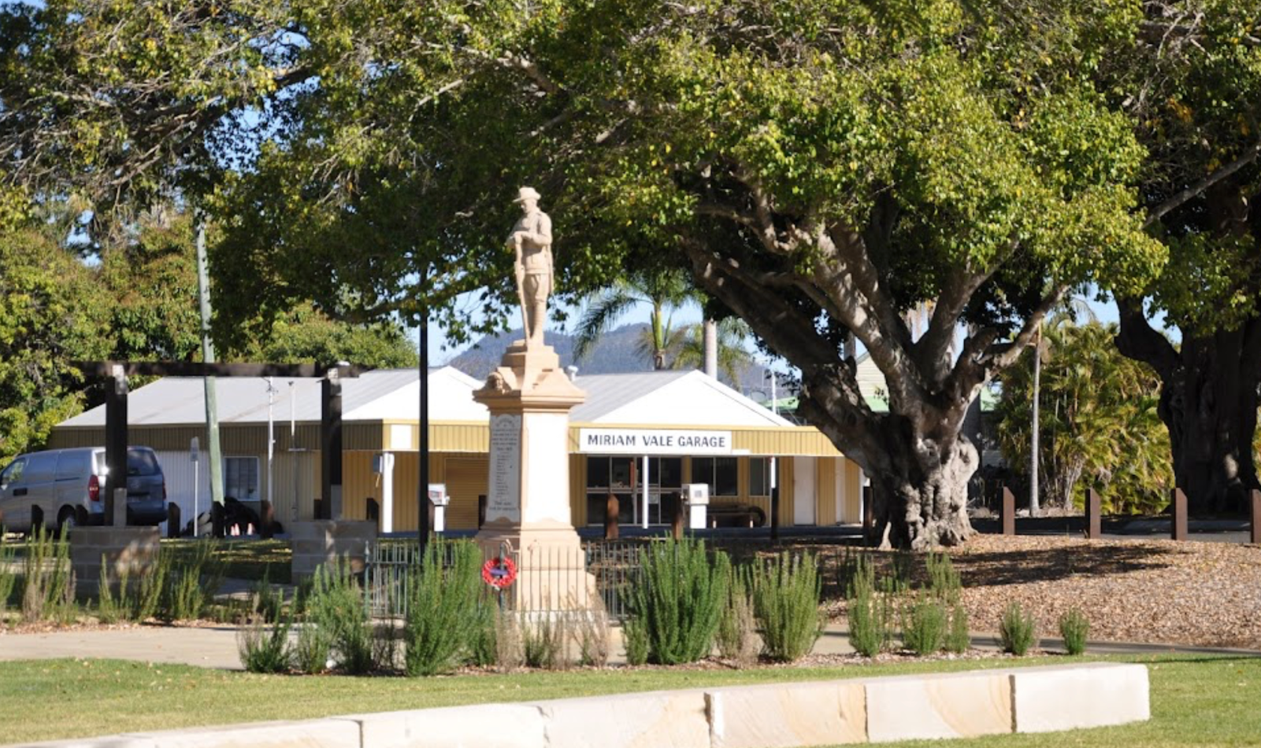

## 

## IMAGE 4 ( 32.88, -117.__ )

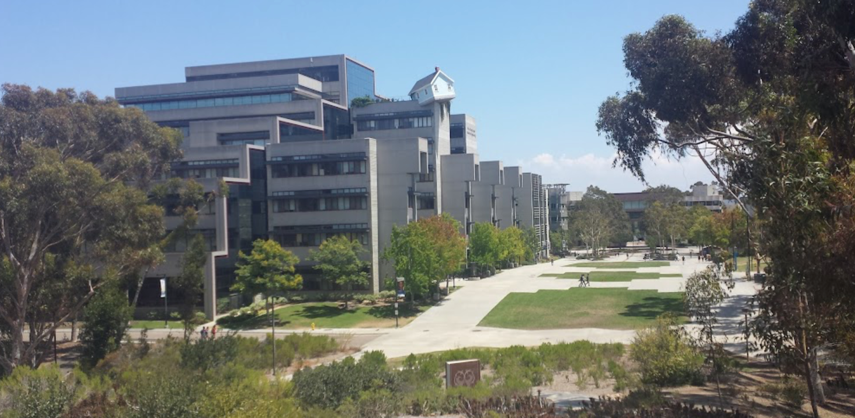

## CIPHER TABLE

This cipher substitutes each letter of the alphabet with a corresponding random numeric value. The numeric values assigned to each letter are as follows:

| **A** | -70 |
| --- | --- |
| **B** | 66 |
| **C** | -33 |
| **D** | 78 |
| **E** | 23 |
| **F** | 17 |
| **G** | 2 |
| **H** | -41 |
| **I** | 5 |
| **J** | -56 |
| **K** | 12 |
| **L** | 151 |
| **M** | -105 |
| **N** | 162 |
| **O** | 92 |
| **P** | -130 |
| **Q** | 87 |
| **R** | 148 |
| **S** | 100 |
| **T** | 53 |
| **U** | -76 |
| **V** | 33 |
| **W** | 10 |
| **X** | 131 |
| **Y** | -160 |
| **Z** | 35 |

## SOLUTION

|  | **Image 1** | **Image 2** | **Image 3** | **Image 4** |
| --- | --- | --- | --- | --- |
| **GPS Coordinate** |  |  |  |  |
| **Decrypted Letter** |  |  |  |  |
| **Name of the accomplice** |  | | | |

## Points

* The group gets 1 point for guessing the GPS coordinate of each image correctly.
* The group gets 3 points for getting the name of the culprit correctly.